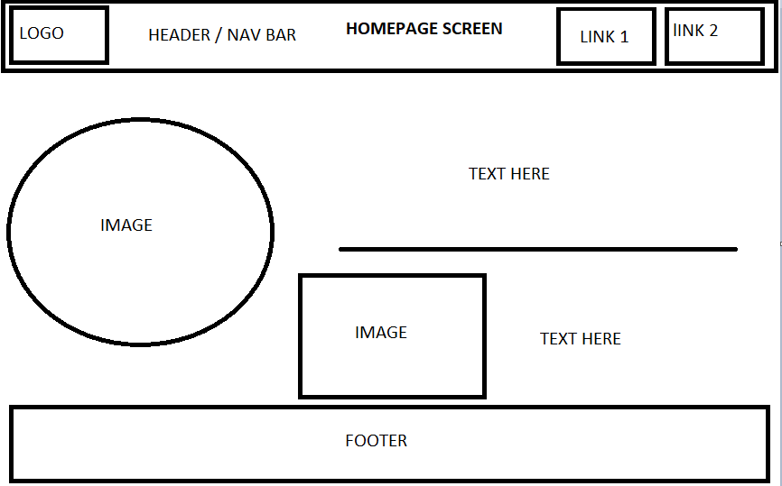

Login page

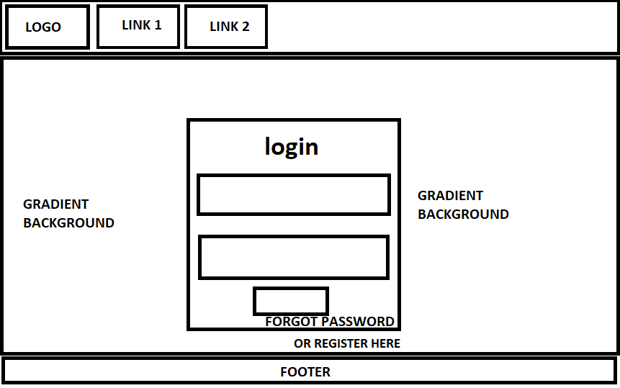

REGISTER FORM

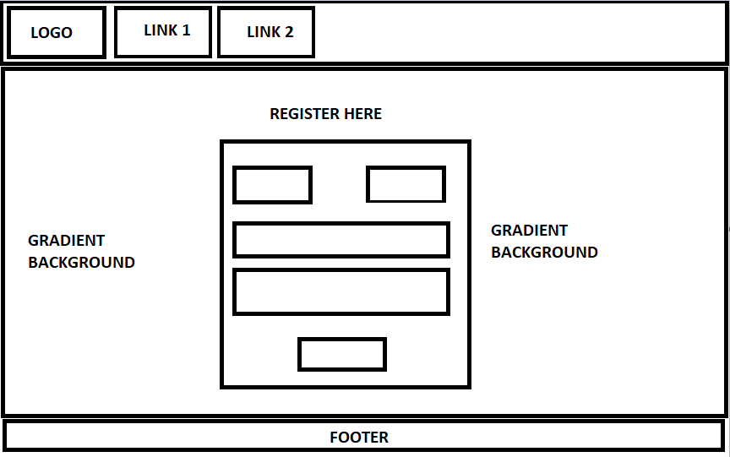

* Enables teacher to monitor learner progress.
* Increases learners engagement and interaction.
* Provides informative feedback for both learner and tutor on learners progress.
* Tutor can set goals and progress points based off of assessment results.
* Less time wasted working out what point the learner is at with the module or unit.

